Lesson Plan #2
Transcontinental Railroad

Introduction:
This lesson is to cover the importance of the transcontinental railroad. It ranges from talking about immigrants, working conditions, and the effects of the railroad.

Objectives:
Content/Knowledge:
- Students will be able to analyze primary sources
- Students will be able to describe the importance of the transcontinental railroad.

Process/Skills:
- Students will be able to gather information on the creation of the railroad
- Students will be able to determine the lasting effects of the railroad through reading accounts from the time

Values/Dispositions:
- Students will be able to analyze primary sources to feel the excitement of this new cross country transportation
- Students will be able to comprehend the hostility towards the new immigrants from Americans.

Standards:

State – Illinois Learning Standards
18.C.4a Analyze major cultural exchanges of the past (e.g., Colombian exchange, the Silk Road, the Crusades)

15.D.4c Describe the impact of worker productivity (output per worker) on business, the worker and the consumer.

15.D.4c Describe the impact of worker productivity (output per worker) on business, the worker and the consumer.

15.D.4c Describe the impact of worker productivity (output per worker) on business, the worker and the consumer.

16.B.4 (US) Identify political ideas that have dominated United States historical eras (e.g., Federalist, Jacksonian, Progressivist, New Deal, New Conservative).

16.B.4 (US) Identify political ideas that have dominated United States historical eras (e.g., Federalist, Jacksonian, Progressivist, New Deal, New Conservative).

16.E.4b (US) Describe different and sometimes competing views, as substantiated by scientific fact, that people in North America have historically held towards the environment (e.g., private and public land ownership and use, resource use vs. preservation).

National – National Council for the Social Studies Standards

1a. Culture: Explore and describe similarities and differences in the ways groups, societies, and cultures address similar human needs and concerns

1b. Culture: give examples of how experiences may be interpreted differently by people from diverse cultural perspectives and frames of reference

Standard 2.d -- Identify and use various sources for reconstructing the past, such as documents, letters, diaries, maps, textbooks, photos and others.

National – National Standards for History

1a. Culture: Explore and describe similarities and differences in the ways groups, societies, and cultures address similar human needs and concerns

1b. Culture: give examples of how experiences may be interpreted differently by people from diverse cultural perspectives and frames of reference

Standard 2.d -- Identify and use various sources for reconstructing the past, such as documents, letters, diaries, maps, textbooks, photos and others.

Common core

CCSS.ELA-Literacy.RH.9-10.7 Integrate quantitative or technical analysis (e.g., charts, research data) with qualitative analysis in print or digital text.
CCSS.ELA-Literacy.RH.9-10.8 Assess the extent to which the reasoning and evidence in a text support the author’s claims.
CCSS.ELA-Literacy.RH.9-10.9 Compare and contrast treatments of the same topic in several primary and secondary sources.

Syntax – Procedures

- White Hat – Objective:
- Teacher Instructions
- Students will come into class and the word transcontinental will be on the board.
- Students will raise their hand and tell the teacher what they believe the word means.
- The teacher will then take what they have said and make a wordle for the student.
- Once students have finished this they will draw a color from a hat
  - Blue, green, yellow, red or black.
- These will be the groups in which the students start off in and will move along in a rotation sense to the left.
- Students will have 10 minutes at each station to complete the task.
- Resource
- Colors on pieces of paper
- Classroom set up with a computer at each station (5)
  - The white station was the opening activity when the student walked in.
- Students should bring a pen or pencil with them to each station.
- Student Activity
- Students will give the teacher different words about what they believe transcontinental means.
- Students and teacher will make a wordle out of these words.
- Students will then pick a color from a hat and that is where they will start the task.

- Red Hat – Intuitive:
a. Teacher Instructions
1. The red station will be about the working conditions of the railroad.
2. Students will analyze a photo of the labor, and they will look at the weather of the Mojave desert and Sierra Nevada range.
3. Students will watch the clip from hell on wheels to get a visual aspect, and the hard work put into making a railroad.
4. The prompt for this section is:
- If you lived in this time what, is your gut reaction to working on the railroad, after reading about the weather and the amount of work put in everyday to lay track? Would you do it? Why or why not?
- Resource
- http://www.sfgate.com/opinion/openforum/article/Railroaded-by-high-speed-rail-3457249.php
- http://www.nps.gov/jotr/naturescience/mojave.htm
- http://www.amctv.com/hell-on-wheels/videos/inside-hell-on-wheels-the-meaning-of-the-railroad

- Student Activity
- Students are to rotate to this station and read about the weather conditions and the amount of work put into the railroad.
- Students will also watch the clip to get a visual aspect of making a railroad.
- Students will then answer prompt that is at station and turn it in at the end of class.

- Black Hat – Negative:
a. Teacher Instructions
1. This station is about the immigrants and the hatred that they faced from the Americans.
2. Students are to use specific website, located below, to determine why the immigrants were treated so badly.
3. There will be a slip of paper that asks a question.
- the question is:
- Why were the immigrant workers treated so badly?
- Resource
- http://www.class.uh.edu/gl/china1.htm
- Slip of paper with question on it
- Student Activity
- Students are to read together the excerpt from the document.
- They will discuss as a group to answer the question.
  - This will be done individually
  - But they will do it as a group and turn it in together

- Yellow Hat – Positive:
- Teacher Instructions
- At this station students will determine why the transcontinental railroad was important.
- The students will have two pictures of the railroad up on the screen along with their captions from the website.
- One picture is of a map of the railroad the other picture is of a train on a bridge.
- The prompt for this station is:
  - What was the importance of the transcontinental? What technological advances did it bring forth?
- Resource
- http://www.tcrr.com/
- prompt on a slip of paper.
- Student Activity
- Students are to rotate to this new area and analyze the picture and the captions they have on the website.
- Students will analyze and read the captions presented on the website.
- The prompt should be answered and turned in individually at the end of the class.

- Green Hat – Creative:
- Teacher Instructions
- At this station students are to design a slogan for their own railroad
- Students will use the pictures of the other signs as a reference
- Students must come up with a slogan, working conditions, and living conditions.
  - They must be realistic and an example from this time period.
- Resource
- http://www.shmoop.com/transcontinental-railroad/photo-over-land-route.html
- Prompt saying:
  - Slogan
  - Working Conditions
  - Living Conditions
  - Must reflect the time period of 1850’s
- Student Activity
- Students will look and analyze the two pictures and design their own railroad slogan
- Students will comprise a list of conditions f their work environment

- Blue Hat – Process:
- Teacher Instructions
- At this station students will have a reflection period on everything they have done so far.
- Students will write a one-paragraph essay about everything they have learned from this section.
- This should be a summary of things they have learned.
- There is one question that must be answered. This question is:
  - Do you think we would be where we are as a country if it we did not have the railroad?
- Resource
1. Piece of paper and pencil
- Student Activity
- Students are to write one paragraph summarizing the information and new knowledge they have over this new section.
- Students must answer the question that is provided along with the summary.

Resources (Source Citations & Bookmarks)

Blue | Blue | Blue | Blue | Blue
Red | Red | Red | Red | Red
Green | Green | Green | Green | Green
Black | Black | Black | Black | Black
Yellow | Yellow | Yellow | Yellow | Yellow

TRANSCONTINENTAL

RED STATION

http://www.amctv.com/hell-on-wheels/videos/inside-hell-on-wheels-the-meaning-of-the-railroad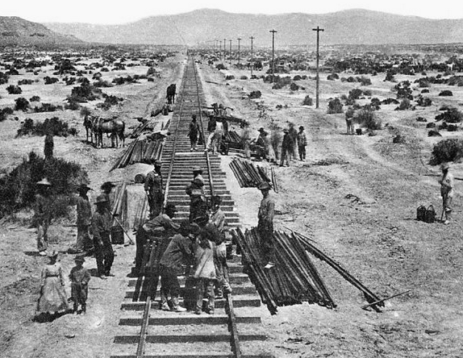
- http://www.nps.gov/jotr/naturescience/mojave.htm

If you lived in this time what, is your gut reaction to working on the railroad, after reading about the weather and the amount of work put in everyday to lay track? Would you do it? Why or why not?

BLACK STATION

http://www.class.uh.edu/gl/china1.htm

Why were the immigrant workers treated so badly?

YELLOW STATION
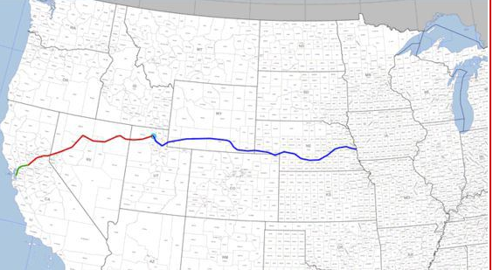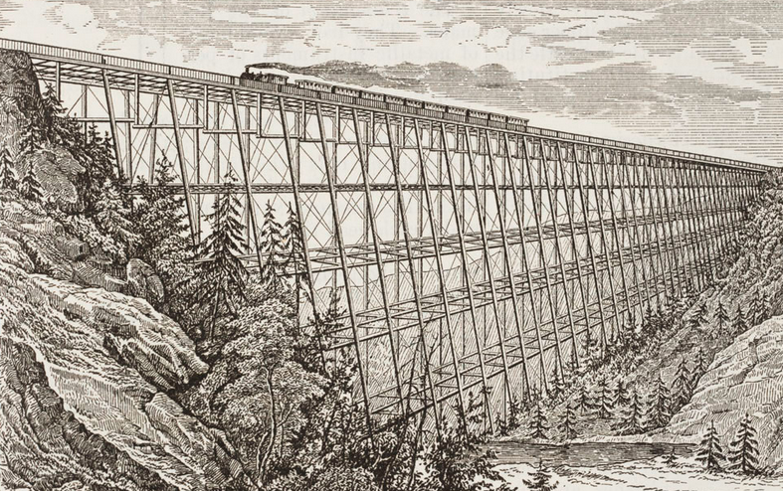

- What was the importance of the transcontinental? What technological advances did it bring forth?

GREEN STATION

- Slogan
- Working Conditions
- Living Conditions
- Must reflect the time period of 1850’s

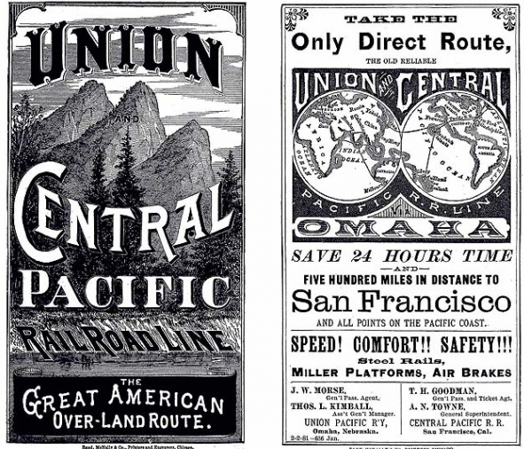

BLUE STATION

- Do you think we would be where we are as a country if it we did not have the railroad?

