Lesson Plan #2
Native Americans culture ending

Introduction:
This section deals with the Native Americans loss of life and culture through the migration west of the new settlers. It covers a wide variety of stories, documents, and biographies of what happened in this tragic time.

Objectives:
Content/Knowledge:
- Students will be able to feel empathy for the native Americans end of culture
- Students will be bale to examine treaties and documents and determine if the politicians were trying to oppress the natives.
- Students will be able to comprehend the loss of life on the trail of tears

Process/Skills:
- Students will be able to analyze primary sources.
- Students will be able to determine the attitude of the American people to the Natives of the lands by reading the treaties
- Students will be able to identify with the native Americans through journals
- Students will be able to write their own journal entry as a native American using primary sources

Values/Dispositions:
- Students will be able to feel compassion for native Americans at the end of their way of life
- Students will be able to determine if the native Americans were victims of a genocide
Standards:

State – Illinois Learning Standards

18.C.4a Analyze major cultural exchanges of the past (e.g., Colombian exchange, the Silk Road, the Crusades)

15.D.4c Describe the impact of worker productivity (output per worker) on business, the worker and the consumer.

15.D.4c Describe the impact of worker productivity (output per worker) on business, the worker and the consumer.

15.D.4c Describe the impact of worker productivity (output per worker) on business, the worker and the consumer.

16.B.4 (US) Identify political ideas that have dominated United States historical eras (e.g., Federalist, Jacksonian, Progressivist, New Deal, New Conservative).

16.B.4 (US) Identify political ideas that have dominated United States historical eras (e.g., Federalist, Jacksonian, Progressivist, New Deal, New Conservative).

16.E.4b (US) Describe different and sometimes competing views, as substantiated by scientific fact, that people in North America have historically held towards the environment (e.g., private and public land ownership and use, resource use vs. preservation).

National – National Council for the Social Studies Standards

1a. Culture: Explore and describe similarities and differences in the ways groups, societies, and cultures address similar human needs and concerns

1b. Culture: give examples of how experiences may be interpreted differently by people from diverse cultural perspectives and frames of reference

Standard 2.d -- Identify and use various sources for reconstructing the past, such as documents, letters, diaries, maps, textbooks, photos and others.

National – National Standards for History

1a. Culture: Explore and describe similarities and differences in the ways groups, societies, and cultures address similar human needs and concerns

1b. Culture: give examples of how experiences may be interpreted differently by people from diverse cultural perspectives and frames of reference

Standard 2.d -- Identify and use various sources for reconstructing the past, such as documents, letters, diaries, maps, textbooks, photos and others.

Common core

CCSS.ELA-Literacy.RH.9-10.7 Integrate quantitative or technical analysis (e.g., charts, research data) with qualitative analysis in print or digital text.
CCSS.ELA-Literacy.RH.9-10.8 Assess the extent to which the reasoning and evidence in a text support the author’s claims.
CCSS.ELA-Literacy.RH.9-10.9 Compare and contrast treatments of the same topic in several primary and secondary sources.

Syntax – Procedures

- Visual/Spatial:
a. Teacher Instructions
1. Teacher will present prezi over the native American removal of land
2. http://prezi.com/okzw_t4bi4ga/us-history-131-cultures-clash-on-the-prairie-132-settling-the-great-plains/
project created by McDaris, Cultures Clash on the Prairie
3. Students will take notes
- should be a review based on book reading from homework on the night previous to class
4. Teacher will ask questions based on the prezi
- what is the importance of the buffalo
- why did the new settlers take the land?
- what were some causes of the moving west of settlers?
- what were the effects of the new settlers moving west?
- What did the dawes act try to do?
5. Stop at section about cowboys

- Resource
- http://prezi.com/okzw_t4bi4ga/us-history-131-cultures-clash-on-the-prairie-132-settling-the-great-plains/
- Students taking notes in journals
.
- Student Activity
- Students are to take notes while the presentation is going on
- Along with writing answers to the questions down, students should write the questions down
  - These will be test questions
- Students and teacher will discuss the questions as we go through the section.

- Logical/Mathematical:
- Teacher Instructions
- Students will watch a movie about the amount of buffalo that were depleted.
- There is a question guide below that goes along with the movie that students should answer and turn in at the end.
- Resource
- http://www.history.com/topics/north-dakota/videos#the-buffalo-and-native-americans
- question sheet, located at the bottom of page.
- Student Activity
- Students will watch the movie and answer the question guide.
- It will be turned in at the end of class.

- Body/Kinesthetic:
a. Teacher Instructions
1. Students will be broken up into 3 groups (Dawes Act, Indian Removal Act, Fort Laramie Treaty).
2. These will be determined by picking a number between 1-3, there will not be even number in the groups since there are 25 students.
3. Students are to go through each rotation and read the treaties or acts.
Students will analyze with a NARA worksheet over articles, each student should have 3.
4. Each group will discuss the articles, located below.
5 Students will answer each worksheet then compare with their group members.

- Resource
- Excerpts locate below
- NARA worksheets
.
- Student Activity
- Students are to get in groups based off of the number they draw out of the hat
- Based on which one they get they will go to that side of the room as a group and read together the articles and answer the questions on the NARA worksheets
- Group 1 is the Dawes Act, Group 2 is the Indian removal act, and group 3 is the Fort Laramie treaty
- Intrapersonal:
- Teacher Instructions
- Students will analyze three photos in the same groups.
- These photos will be passed out after the students finished the first set of rotations.
- Photos are a political cartoon, and 2 paintings.
- They can be handed out randomly to groups, and the students can rotate around them.
- Resource
- 3 photos (1 cartoon, 2 paintings).
- NARA photo document anaylsis
- Student Activity
- Students should stay in their groups they are in now.
- Documents with pictures on them will be handed out
- Along with the NARA photo analysis sheet
- Students are to fill these out and turn them in at the end of class

- Musical/Rhythmic:
- Teacher Instructions
- Students will come back together and sit at their desks and listen to a song.
- This song is a Cherokee morning song with lyrics.
- Students are to listen and write down interesting lyric translations that they find.
- We will discuss them after the song
- Teacher will pass out the lyrics
- Resource
- http://www.youtube.com/watch?v=YhcgX1VHsgk
- pen or pencil
- paper
- Student Activity
- Students will get back to their seats and listen to the song
- Students will have a piece of paper out with them as we go along with the song
- Students will write down interesting lyrics so we can discuss them as a class after the song.
- Students will have copy of the lyrics passed out by the teacher

- Verbal/Linguistic:
- Teacher Instructions
- Students are to stay seated and read the poem individually.
- Teacher will pass out the packet of poem and worksheet over the poem
- Once they have finished students will go through and answer the questions on the worksheet
- Students will find a partner and talk about the questions for 3-5 minutes
- Once they have finished talking with a partner over the 3 questions, students will turn that sheet in to at the end of class.
- Resource
- Poem hand out.
- 3 questions over the poem

- Student Activity
- Individually the students will look at the poem and answer the questions provided to them by the teacher.
- Once finished students will find a partner and talk to them what they found through the poem.
- Students will return to their seats and get ready for the next part by taking out a piece of paper and pencil.

- Naturalist:
- Teacher Instructions
- Once students have returned to their seats they should take out a piece of paper and pencil.
- Students are to write down the numbers 1-5.
- They will be having a pop quiz at the end of class to see how much they learned.
- The questions are:
  - What did the Dawes Act try and do?
  - What is a reservation?
  - Why did americans take over the native’s land?
  - Why did the buffalo die out?
  - What was a name of a conflict between settlers and the naives? Why did it take place?
- Worth 10 points

- Resource
- Paper and pencil
.
- Student Activity
- Students will be taking a pop quiz
- The students are being assessed on what they learned it will be worth 10 points.

- Interpersonal:
- Teacher Instructions
- For homework students are to act as if they are a native American on the trail of tears and tell a story about their journey.
- It should include hardships, and talk about other challenges faced by natives on these trips.
- This will have a rubric attached to it also so the students can stay on task.
- It should be anywhere between 1-2pages
- With at least 3 journal entries.

- Resource
- rubric located below

- Student Activity
- Student will be writing a journal excerpt as a native American there same age.
- They are to include hardships, and other things a native American may face at this time.
- 1-2 pages at least 3 journal entries

Resources (Source Citations & Bookmarks)

BUFFALO MOVIE WORKSHEET

What were the teeth used for?

What was the importance of the hair?

What was the strangest body part, according to you, used for?

How many buffalo roamed at the turn of the 19th century? How many by 1910?

Why do you think the settlers were not as stingy as the natives when concerning buffalo?
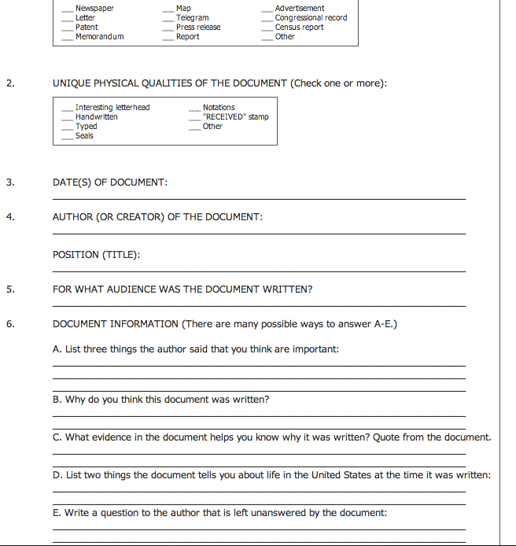

Dawes Act

Federal Indian policy during the period from 1870 to 1900 marked a departure from earlier policies that were dominated by removal, treaties, reservations, and even war. The new policy focused specifically on breaking up reservations by granting land allotments to individual Native Americans. Very sincere individuals reasoned that if a person adopted white clothing and ways, and was responsible for his own farm, he would gradually drop his Indian-ness and be assimilated into the population. It would then no longer be necessary for the government to oversee Indian welfare in the paternalistic way it had been obligated to do, or provide meager annuities that seemed to keep the Indian in a subservient and poverty-stricken position.
On February 8, 1887, Congress passed the Dawes Act, named for its author, Senator Henry Dawes of Massachusetts. Also known as the General Allotment Act, the law allowed for the President to break up reservation land, which was held in common by the members of a tribe, into small allotments to be parceled out to individuals. Thus, Native Americans registering on a tribal "roll" were granted allotments of reservation land. “To each head of a family, one-quarter of a section; To each single person over eighteen years of age, one-eighth of a section ; To each orphan child under eighteen years of age, one-eighth of a section; and To each other single person under eighteen years now living, or who may be born prior to the date of the order of the President directing an allotment of the lands embraced in any reservation, one-sixteenth of a section…”
Section 8 of the act specified groups that were to be exempt from the law. It stated that "the provisions of this act shall not extend to the territory occupied by the Cherokees, Creeks, Choctaws, Chickasaws, Seminoles, and Osage, Miamies and Peorias, and Sacs and Foxes, in the Indian Territory, nor to any of the reservations of the Seneca Nation of New York Indians in the State of New York, nor to that strip of territory in the State of Nebraska adjoining the Sioux Nation on the south."
Subsequent events, however, extended the act's provisions to these groups as well. In 1893 President Grover Cleveland appointed the Dawes Commission to negotiate with the Cherokees, Creeks, Choctaws, Chickasaws, and Seminoles, who were known as the Five Civilized Tribes. As a result of these negotiations, several acts were passed that allotted a share of common property to members of the Five Civilized Tribes in exchange for abolishing their tribal governments and recognizing state and Federal laws. In order to receive the allotted land, members were to enroll with the Bureau of Indian Affairs. Once enrolled, the individual's name went on the "Dawes rolls." This process assisted the BIA and the Secretary of the Interior in determining the eligibility of individual members for land distribution.
The purpose of the Dawes Act and the subsequent acts that extended its initial provisions was purportedly to protect Indian property rights, particularly during the land rushes of the 1890s, but in many instances the results were vastly different. The land allotted to the Indians included desert or near-desert lands unsuitable for farming. In addition, the techniques of self-sufficient farming were much different from their tribal way of life. Many Indians did not want to take up agriculture, and those who did want to farm could not afford the tools, animals, seed, and other supplies necessary to get started. There were also problems with inheritance. Often young children inherited allotments that they could not farm because they had been sent away to boarding schools. Multiple heirs also caused a problem; when several people inherited an allotment, the size of the holdings became too small for efficient farming.
http://www.ourdocuments.gov/doc.php?flash=true&doc=50

Begun and held at the City of Washington on Monday, the sixth day of December, one thousand eight hundred and eight-six.
An Act to provide for the allotment of lands in severalty to Indians on the various reservations, and to extend the protection of the laws of the United States and the Territories over the Indians, and for other purposes.
Be it enacted by the Senate and House of Representatives of the United States of America in Congress assembled, That in all cases where any tribe or band of Indians has been, or shall hereafter be, located upon any reservation created for their use, either by treaty stipulation or by virtue of an act of Congress or executive order setting apart the same for their use, the President of the United States be, and he hereby is, authorized, whenever in his opinion any reservation or any part thereof of such Indians is advantageous for agricultural and grazing purposes, to cause said reservation, or any part thereof, to be surveyed, or resurveyed if necessary, and to allot the lands in said reservation in severalty to any Indian located thereon in quantities as follows:
To each head of a family, one-quarter of a section;
To each single person over eighteen years of age, one-eighth of a section;
To each orphan child under eighteen years of age, one-eighth of a section; and
To each other single person under eighteen years now living, or who may be born prior to the date of the order of the President directing an allotment of the lands embraced in any reservation, one-sixteenth of a section:
Provided, That in case there is not sufficient land in any of said reservations to allot lands to each individual of the classes above named in quantities as above provided, the lands embraced in such reservation or reservations shall be allotted to each individual of each of said classes pro rata in accordance with the provisions of this act: And provided further, That where the treaty or act of Congress setting apart such reservation provides the allotment of lands in severalty in quantities in excess of those herein provided, the President, in making allotments upon such reservation, shall allot the lands to each individual Indian belonging thereon in quantity as specified in such treaty or act: And provided further, That when the lands allotted are only valuable for grazing purposes, an additional allotment of such grazng lands, in quantities as above provided, shall be made to each individual.
Sec. 2. That all allotments set apart under the provisions of this act shall be selected by the Indians, heads of families selecting for their minor children, and the agents shall select for each orphan child, and in such manner as to embrace the improvements of the Indians making the selection. where the improvements of two or more Indians have been made on the same legal subdivision of land, unless they shall otherwise agree, a provisional line may be run dividing said lands between them, and the amount to which each is entitled shall be equalized in the assignment of the remainder of the land to which they are entitled under his act: Provided, That if any one entitled to an allotment shall fail to make a selection vithin four years after the President shall lirect that allotments may be made on a particular reservation, the Secretary of the Interior may direct the agent of such tribe or band, if such there be, and if there be no agent, then a special agent appointed for that purpose, to make a selection for such Indian, which selection shall be allotted as in cases where selections are made by the Indians, and patents shall issue in like manner.
Sec. 3. That the allotments provided for in this act shall be made by special agents appointed by the President for such purpose, and the agents in charge of the respective reservations on which the allotments are directed to be made, under such rules and regulations as the Secretary of the Interior may from time to time prescribe, and shall be certified by such agents to the Commissioner of Indian Affairs, in duplicate, one copy to be retained in the Indian Office and the other to be transmitted to the Secretary of the Interior for his action, and to be deposited in the General Land Office.
Sec. 4. That where any Indian not residing upon a reservation, or for whose tribe no reservation has been provided by treaty, act of Congress, or executive order, shall make settlement upon any surveyed or unsurveyed lands of the United States not otherwise appropriated, he or she shall be entitled, upon application to the local land-office for the district in which the lands arc located, to have the same allotted to him or her, and to his or her children, in quantities and manner as provided in this act for Indians residing upon reservations; and when such settlement is made upon unsurveyed lands, the grant to such Indians shall be adjusted upon the survey of the lands so as to conform thereto; and patents shall be issued to them for such lands in the manner and with the restrictions as herein provided. And the fees to which the officers of such local land-office would have been entitled had such lands been entered under the general laws for the disposition of the public lands shall be paid to them, from any moneys in the Treasury of the United States not otherwise appropriated, upon a statement of an account in their behalf for such fees by the Commissioner of the General Land Office, and a certification of such account to the Secretary of the Treasury by the Secretary of the Interior.
Sec. 5. That upon the approval of the allotments provided for in this act by the Secretary of the Interior, he shall cause patents to issue therefor in the name of the allottees, which patents shall be of the legal effect, and declare that the United States does and will hold the land thus allotted, for the period of twenty-five years, in trust for the sole use and benefit of the Indian to whom such allotment shall have been made, or, in case of his decease, of his heirs according to the laws of the State or Territory where such land is located, and that at the expiration of said period the United States will convey the same by patent to said Indian, or his heirs as aforesaid, in fee, discharged of said trust and free of all charge or incumbrance whatsoever: Provided, That the President of the United States may in any case in his discretion extend the period. And if any conveyance shall be made of the lands set apart and allotted as herein provided, or any contract made touching the same, before the expiration of the time above mentioned, such conveyance or contract shall be absolutely null and void: Provided, That the law of descent and partition in force in the State or Territory where such lands are situate shall apply thereto after patents therefor have been executed and delivered, except as herein otherwise provided; and the laws of the State of Kansas regulating the descent and partition of real estate shall, so far as practicable, apply to all lands in the Indian Territory which may be allotted in severalty under the provisions of this act: And provided further, That at any time after lands have been allotted to all the Indians of any tribe as herein provided, or sooner if in the opinion of the President it shall be for the best interests of said tribe, it shall be lawful for the Secretary of the Interior to negotiate with such Indian tribe for the purchase and release by said tribe, in conformity with the treaty or statute under which such reservation is held, of such portions of its reservation not allotted as such tribe shall, from time to time, consent to sell, on such terms and conditions as shall be considered just and equitable between the United States and said tribe of Indians, which purchase shall not be complete until ratified by Congress, and the form and manner of executing such release prescribed by Congress: Provided however, That all lands adapted to agriculture, with or without irrigation so sold or released to the United States by any Indian tribe shall be held by the United States for the sale purpose of securing homes to actual settlers and shall be disposed of by the United States to actual and bona fide settlers only tracts not exceding one hundred and sixty acres to any one person, on such terms as Congress shall prescribe, subject to grants which Congress may make in aid of education: And provided further, That no patents shall issue therefor except to the person so taking the same as and homestead, or his heirs, and after the expiration of five years occupancy therof as such homestead; and any conveyance of said lands taken as a homestead, or any contract touching the same, or lieu thereon, created prior to the date of such patent, shall be null and void. And the sums agreed to be paid by the United States as purchase money for any portion of any such reservation shall be held in the Treasury of the United States for the sole use of the tribe or tribes Indians; to whom such reservations belonged; and the same, with interest thereon at three per cent per annum, shall be at all times subject to appropriation by Congress for the education and civilization of such tribe or tribes of Inians or the members thereof. The patents aforesaid shall be recorded in the General Land Office, and afterward delivered, free of charge, to the allottee entitled thereto. And if any religious society or other organization is now occupying any of the public lands to which this act is applicable, for religious or educationl work among the Indians, the Secretary of the Interior is hereby authorized to confirm such occupation to such society or organization, in quantity not exceeding one hundred and sixty acres in any one tract, so long as the same shall be so occupied, on such terms as he shall deem just; but nothing herein contained shall change or alter any claim of such society for religious or educational purposes heretofore granted by law. And hereafter in the employment of Indian police, or any other employes in the public service among any of the Indian tribes or bands affected by this act, and where Indians can perform the duties required, those Indians who have availed themselves of the provisions of this act and become citizens of the United States shall be preferred.
Sec. 6. That upon the completion ef said allotments and the patenting of the lands to said allottees, each and every nmmber of the respective bands or tribes of Indians to whom allotments have been made shall have the benefit of and be subject to the laws, both civil and criminal, of the State or Territory in which they may reside; and no Territory shall pass or enforce any law denying any such Indian within its jurisdiction the equal protection of the law. And every Indian born within the territorial limits of the United States to whom allotments shall have been made under the provisions of this act, or under any law or treaty, and every Indian born within the territorial limits of the United States who has voluntarily taken up, within said limits, his residence separate and apart from any tribe of Indians therein, and has adopted the habits of civilized life, is hereby declared to be a citizen of the United States, and is entitled to all the rights, privileges, and immunities of such citizens, whether said Indian has been or not, by birth or otherwise, a member of any tribe of Indians within the territorial limits of the United States without in any manner affecting the right of any such Indian to tribal or other property.
Sec. 7. That in cases where the use of water for irrigation is necessary to render the lands within any Indian reservation available for agricultural purposes, the Secretary of the Interior be, and he is hereby, authorized to prescribe such rules and regulations as he may deem necessary to secure a just and equal distribution thereof among the Indians residing upon any such reservation; and no oother appropriation or grant of water by any riparian proprietor shall permitted to the damage of any other riparian proprietor.
Sec. 8. That the provisions of this act shall not extend to the territory occupied by the Cherokees, Creeks, Choctaws, Chickasaws, Seminoles, and Osage, Miamies and Peorias, and Sacs and Foxes, in the Indian Territory, nor to any of the reservations of the Seneca Nation of New York Indians in the State of New York, nor to that strip of territory in the State of Nebraska adjoining the Sioux Nation on the south added by executive order.
Sec. 9. That for the purpose of making the surveys and resurveys mentioned in section two of this act, there be, and hereby is, appropriated, out of any moneys in the Treasury not otherwise appropriated, the sum of one hundred thousand dollars, to be repaid proportionately out of the proceeds of the sales of such land as may be acquired from the Indians under the provisions of this act.
Sec. 10. That nothing in this act contained shall be so canstrued to affect the right and power of Congress to grant the right of way through any lands granted to an Indian, or a tribe of Indians, for railroads or other highways, or telegraph lines, for the public use, or condemn such lands to public uses, upon making just compensation.
Sec. 11. That nothing in this act shall be so construed as to prevent the removal of the Southern Ute Indians from their present reservation in Southwestern Colorado to a new reservation by and with consent of a majority of the adult male members of said tribe.

Fort Laramie Treaty

Fort Laramie Treaty
The history of Native Americans in North America dates back thousands of years. Exploration and settlement of the United States by Americans and Europeans wreaked havoc on the Indian peoples living there. In the 19th century the American drive for expansion clashed violently with the Native American resolve to preserve their lands, sovereignty, and ways of life. The struggle over land has defined relations between the U.S. Government and Native Americans.
From the 1860s through the 1870s the American frontier was filled with Indian wars and skirmishes. In 1865 a congressional committee began a study of the Indian uprisings and wars in the West, resulting in a “Report on the Condition of the Indian Tribes,” which was released in 1867. This study and report by the congressional committee led to an act to establish an Indian Peace Commission to end the wars and prevent future Indian conflicts. The U.S. Government set out to establish a series of Indian treaties that would force the Indians to give up their lands and move further west onto reservations. In the spring of 1868 a conference was held at Fort Laramie, in present day Wyoming, which resulted in a treaty with the Sioux. This treaty was to bring peace between the whites and the Sioux who agreed to settle within the Black Hills reservation in the Dakota Territory.
The Black Hills of Dakota are sacred to the Sioux Indians. In the 1868 treaty, signed at Fort Laramie and other military posts in Sioux country, the United States recognized the Black Hills as part of the Great Sioux Reservation, set aside for exclusive use by the Sioux people. In 1874, however, Gen. George A. Custer led an expedition into the Black Hills accompanied by miners who were seeking gold. Once gold was found in the Black Hills, miners were soon moving into the Sioux hunting grounds and demanding protection from the U.S. Army. Soon, the Army was ordered to move against wandering bands of Sioux hunting on the range in accordance with their treaty rights. In 1876, Custer, leading an army detachment, encountered the encampment of Sioux and Cheyenne at the Little Bighorn River. Custer's detachment was annihilated, but the United States would continue its battle against the Sioux in the Black Hills until the government confiscated the land in 1877. To this day, ownership of the Black Hills remains the subject of a legal dispute between the U.S. Government and the Sioux.
http://www.ourdocuments.gov/doc.php?flash=true&doc=42

Lieutenant General William T. Sherman, General William S. Harney, General Alfred H. Terry, General O. O. Augur, J. B. Henderson, Nathaniel G. Taylor, John G. Sanborn, and Samuel F. Tappan, duly appointed commissioners on the part of the United States, and the different bands of the Sioux Nation of Indians, by their chiefs and headmen, whose names are hereto subscribed, they being duly authorized to act in the premises.
ARTICLE I.
From this day forward all war between the parties to this agreement shall for ever cease. The government of the United States desires peace, and its honor is hereby pledged to keep it. The Indians desire peace, and they now pledge their honor to maintain it.
If bad men among the whites, or among other people subject to the authority of the United States, shall commit any wrong upon the person or property of the Indians, the United States will, upon proof made to the agent, and forwarded to the Commissioner of Indian Affairs at Washington city, proceed at once to cause the offender to be arrested and punished according to the laws of the United States, and also reimburse the injured person for the loss sustained.
If bad men among the Indians shall commit a wrong or depredation upon the person or property of nay one, white, black, or Indian, subject to the authority of the United States, and at peace therewith, the Indians herein named solemnly agree that they will, upon proof made to their agent, and notice by him, deliver up the wrongdoer to the United States, to be tried and punished according to its laws, and, in case they willfully refuse so to do, the person injured shall be reimbursed for his loss from the annuities, or other moneys due or to become due to them under this or other treaties made with the United States; and the President, on advising with the Commissioner of Indian Affairs, shall prescribe such rules and regulations for ascertaining damages under the provisions of this article as in his judgment may be proper, but no one sustaining loss while violating the provisions of this treaty, or the laws of the United States, shall be reimbursed therefor.
ARTICLE II.
The United States agrees that the following district of country, to wit, viz: commencing on the east bank of the Missouri river where the 46th parallel of north latitude crosses the same, thence along low-water mark down said east bank to a point opposite where the northern line of the State of Nebraska strikes the river, thence west across said river, and along the northern line of Nebraska to the 104th degree of longitude west from Greenwich, thence north on said meridian to a point where the 46th parallel of north latitude intercepts the same, thence due east along said parallel to the place of beginning; and in addition thereto, all existing reservations of the east back of said river, shall be and the same is, set apart for the absolute and undisturbed use and occupation of the Indians herein named, and for such other friendly tribes or individual Indians as from time to time they may be willing, with the consent of the United States, to admit amongst them; and the United States now solemnly agrees that no persons, except those herein designated and authorized so to do, and except such officers, agents, and employees of the government as may be authorized to enter upon Indian reservations in discharge of duties enjoined by law, shall ever be permitted to pass over, settle upon, or reside in the territory described in this article, or in such territory as may be added to this reservation for the use of said Indians, and henceforth they will and do hereby relinquish all claims or right in and to any portion of the United States or Territories, except such as is embraced within the limits aforesaid, and except as hereinafter provided.
ARTICLE III.
If it should appear from actual survey or other satisfactory examination of said tract of land that it contains less than 160 acres of tillable land for each person who, at the time, may be authorized to reside on it under the provisions of this treaty, and a very considerable number of such persons hsall be disposed to comence cultivating the soil as farmers, the United States agrees to set apart, for the use of said Indians, as herein provided, such additional quantity of arable land, adjoining to said reservation, or as near to the same as it can be obtained, as may be required to provide the necessary amount.
ARTICLE IV.
The United States agrees, at its own proper expense, to construct, at some place on the Missouri river, near the centre of said reservation where timber and water may be convenient, the following buildings, to wit, a warehouse, a store-room for the use of the agent in storing goods belonging to the Indians, to cost not less than $2,500; an agency building, for the residence of the agent, to cost not exceeding $3,000; a residence for the physician, to cost not more than $3,000; and five other buildings, for a carpenter, farmer, blacksmith, miller, and engineer-each to cost not exceeding $2,000; also, a school-house, or mission building, so soon as a sufficient number of children can be induced by the agent to attend school, which shall not cost exceeding $5,000.
The United States agrees further to cause to be erected on said reservation, near the other buildings herein authorized, a good steam circular saw-mill, with a grist-mill and shingle machine attached to the same, to cost not exceeding $8,000.
ARTICLE V.
The United States agrees that the agent for said Indians shall in the future make his home at the agency building; that he shall reside among them, and keep an office open at all times for the purpose of prompt and diligent inquiry into such matters of complaint by and against the Indians as may be presented for investigation under the provisions of their treaty stipulations, as also for the faithful discharge of other duties enjoined on him by law. In all cases of depredation on person or property he shall cause the evidence to be taken in writing and forwarded, together with his findings, to the Commissioner of Indian Affairs, whose decision, subject to the revision of the Secretary of the Interior, shall be binding on the parties to this treaty.
ARTICLE VI.
If any individual belonging to said tribes of Indians, or legally incorporated with them, being the head of a family, shall desire to commence farming, he shall have the privilege to select, in the presence and with the assistance of the agent then in charge, a tract of land within said reservation, not exceeding three hundred and twenty acres in extent, which tract, when so selected, certified, and recorded in the "Land Book" as herein directed, shall cease to be held in common, but the same may be occupied and held in the exclusive possession of the person selecting it, and of his family, so long as he or they may continue to cultivate it.
Any person over eighteen years of age, not being the head of a family, may in like manner select and cause to be certified to him or her, for purposes of cultivation, a quantity of land, not exceeding eighty acres in extent, and thereupon be entitled to the exclusive possession of the same as above directed.
For each tract of land so selected a certificate, containing a description thereof and the name of the person selecting it, with a certificate endorsed thereon that the same has been recorded, shall be delivered to the party entitled to it, by the agent, after the same shall have been recorded by him in a book to be kept in his office, subject to inspection, which said book shall be known as the "Sioux Land Book."
The President may, at any time, order a survey of the reservation, and, when so surveyed, Congress shall provide for protecting the rights of said settlers in their improvements, and may fix the character of the title held by each. The United States may pass such laws on the subject of alienation and descent of property between the Indians and their descendants as may be thought proper. And it is further stipulated that any male Indians over eighteen years of age, of any band or tribe that is or shall hereafter become a party to this treaty, who now is or who shall hereafter become a resident or occupant of any reservation or territory not included in the tract of country designated and described in this treaty for the permanent home of the Indians, which is not mineral land, nor reserved by the United States for special purposes other than Indian occupation, and who shall have made improvements thereon of the value of two hundred dollars or more, and continuously occupied the same as a homestead for the term of three years, shall be entitled to receive from the United States a patent for one hundred and sixty acres of land including his said improvements, the same to be in the form of the legal subdivisions of the surveys of the public lands. Upon application in writing, sustained by the proof of two disinterested witnesses, made to the register of the local land office when the land sought to be entered is within a land district, and when the tract sought to be entered is not in any land district, then upon said application and proof being made to the Commissioner of the General Land Office, and the right of such Indian or Indians to enter such tract or tracts of land shall accrue and be perfect from the date of his first improvements thereon, and shall continue as long as be continues his residence and improvements and no longer. And any Indian or Indians receiving a patent for land under the foregoing provisions shall thereby and from thenceforth become and be a citizen of the United States and be entitled to all the privileges and immunities of such citizens, and shall, at the same time, retain all his rights to benefits accruing to Indians under this treaty.
ARTICLE VII.
In order to insure the civilization of the Indians entering into this treaty, the necessity of education is admitted, especially of such of them as are or may be settled on said agricultural reservations, and they, therefore, pledge themselves to compel their children, male and female, between the ages of six and sixteen years, to attend school, and it is hereby made the duty of the agent for said Indians to see that this stipulation is strictly complied with; and the United States agrees that for every thirty children between said ages, who can be induced or compelled to attend school, a house shall be provided, and a teacher competent to teach the elementary branches of an English education shall be furnished, who will reside among said Indians and faithfully discharge his or her duties as a teacher. The provisions of this article to continue for not less than twenty years.
ARTICLE VIII.
When the head of a family or lodge shall have selected lands and received his certificate as above directed, and the agent shall be satisfied that he intends in good faith to commence cultivating the soil for a living, he shall be entitled to receive seeds and agricultural implements for the first year, not exceeding in value one hundred dollars, and for each succeeding year he shall continue to farm, for a period of three years more, he shall be entitled to receive seeds and implements as aforesaid, not exceeding in value twenty-five dollars. And it is further stipulated that such persons as commence farming shall receive instruction from the farmer herein provided for, and whenever more than one hundred persons shall enter upon the cultivation of the soil, a second blacksmith shall be provided, with such iron, steel, and other material as may be needed.
ARTICLE IX.
At any time after ten years fro the making of this treaty, the United States shall have the privilege of withdrawing the physician, farmer, blacksmith, carpenter, engineer, and miller herein provided for, but in case of such withdrawal, an additional sum thereafter of ten thousand dollars per annum shall be devoted to the education of said Indians, and the Commissioner of Indian Affairs shall, upon careful inquiry into their condition, make such rules and regulations for the expenditure of said sums as will best promote the education and moral improvement of said tribes.
ARTICLE X.
In lieu of all sums of money or other annuities provided to be paid to the Indians herein named under any treaty or treaties heretofore made, the United States agrees to deliver at the agency house on the reservation herein named, on or before the first day of August of each year, for thirty years, the following articles, to wit:
For each male person over 14 years of age, a suit of good substantial woollen clothing, consisting of coat, pantaloons, flannel shirt, hat, and a pair of home-made socks.
For each female over 12 years of age, a flannel shirt, or the goods necessary to make it, a pair of woollen hose, 12 yards of calico, and 12 yards of cotton domestics.
For the boys and girls under the ages named, such flannel and cotton goods as may be needed to make each a suit as aforesaid, together with a pair of woollen hose for each.
And in order that the Commissioner of Indian Affairs may be able to estimate properly for the articles herein named, it shall be the duty of the agent each year to forward to him a full and exact census of the Indians, on which the estimate from year to year can be based.
And in addition to the clothing herein named, the sum of $10 for each person entitled to the beneficial effects of this treaty shall be annually appropriated for a period of 30 years, while such persons roam and hunt, and $20 for each person who engages in farming, to be used by the Secretary of the Interior in the purchase of such articles as from time to time the condition and necessities of the Indians may indicate to be proper. And if within the 30 years, at any time, it shall appear that the amount of money needed for clothing, under this article, can be appropriated to better uses for the Indians named herein, Congress may, by law, change the appropriation to other purposes, but in no event shall the amount of the appropriation be withdrawn or discontinued for the period named. And the President shall annually detail an officer of the army to be present and attest the delivery of all the goods herein named, to the Indians, and he shall inspect and report on the quantity and quality of the goods and the manner of their delivery. And it is hereby expressly stipulated that each Indian over the age of four years, who shall have removed to and settled permanently upon said reservation, one pound of meat and one pound of flour per day, provided the Indians cannot furnish their own subsistence at an earlier date. And it is further stipulated that the United States will furnish and deliver to each lodge of Indians or family of persons legally incorporated with the, who shall remove to the reservation herein described and commence farming, one good American cow, and one good well-broken pair of American oxen within 60 days after such lodge or family shall have so settled upon said reservation.
ARTICLE XI.
In consideration of the advantages and benefits conferred by this treaty and the many pledges of friendship by the United States, the tribes who are parties to this agreement hereby stipulate that they will relinquish all right to occupy permanently the territory outside
their reservations as herein defined, but yet reserve the right to hunt on any lands north of North Platte, and on the Republican Fork of the Smoky Hill river, so long as the buffalo may range thereon in such numbers as to justify the chase. And they, the said Indians, further expressly agree:
1st. That they will withdraw all opposition to the construction of the railroads now being built on the plains.
2d. That they will permit the peaceful construction of any railroad not passing over their reservation as herein defined.
3d. That they will not attack any persons at home, or travelling, nor molest or disturb any wagon trains, coaches, mules, or cattle belonging to the people of the United S
tates, or to persons friendly therewith.
4th. They will never capture, or carry off from the settlements, white women or children.
5th. They will never kill or scalp white men, nor attempt to do them harm.
6th. They withdraw all pretence of opposition to the construction of the railroad now being built along the Platte river and westward to the Pacific ocean, and they will not in future object to the construction of railroads, wagon roads, mail stations, or other works of utility or necessity, which may be ordered or permitted by the laws of the United States. But should such roads or other works be constructed on the lands of their reservation, the government will pay the tribe whatever amount of damage may be assessed by three disinterested commissioners to be appointed by the President for that purpose, one of the said commissioners to be a chief or headman of the tribe.
7th. They agree to withdraw all opposition to the military posts or roads now established south of the North Platte river, or that may be established, not in violation of treaties heretofore made or hereafter to be made with any of the Indian tribes.
ARTICLE XII.
No treaty for the cession of any portion or part of the reservation herein described which may be held in common, shall be of any validity or force as against the said Indians unless executed and signed by at least three-fourths of all the adult male Indians occupying or interested in the same, and no cession by the tribe shall be understood or construed in such manner as to deprive, without his consent, any individual member of the tribe of his rights to any tract of land selected by him as provided in Article VI of this treaty.
ARTICLE XIII.
The United States hereby agrees to furnish annually to the Indians the physician, teachers, carpenter, miller, engineer, farmer, and blacksmiths, as herein contemplated, and that such appropriations shall be made from time to time, on the estimate of the Secretary of the Interior, as will be sufficient to employ such persons.
ARTICLE XIV.
It is agreed that the sum of five hundred dollars annually for three years from date shall be expended in presents to the ten persons of said tribe who in the judgment of the agent may grow the most valuable crops for the respective year.
ARTICLE XV.
The Indians herein named agree that when the agency house and other buildings shall be constructed on the reservation named, they will regard said reservation their permanent home, and they will make no permanent settlement elsewhere; but they shall have the right, subject to the conditions and modifications of this treaty, to hunt, as stipulated in Article XI hereof.
ARTICLE XVI.
The United States hereby agrees and stipulates that the country north of the North Platte river and east of the summits of the Big Horn mountains shall be held and considered to be unceded. Indian territory, and also stipulates and agrees that no white person or persons shall be permitted to settle upon or occupy any portion of the same; or without the consent of the Indians, first had and obtained, to pass through the same; and it is further agreed by the United States, that within ninety days after the conclusion of peace with all the bands of the Sioux nation, the military posts now established in the territory in this article named shall be abandoned, and that the road leading to them and by them to the settlements in the Territory of Montana shall be closed.
ARTICLE XVII.
It is hereby expressly understood and agreed by and between the respective parties to this treaty that the execution of this treaty and its ratification by the United States Senate shall have the effect, and shall be construed as abrogating and annulling all treaties and agreements heretofore entered into between the respective parties hereto, so far as such treaties and agreements obligate the United States to furnish and provide money, clothing, or other articles of property to such Indians and bands of Indians as become parties to this treaty, but no further.
In testimony of all which, we, the said commissioners, and we, the chiefs and headmen of the Brule band of the Sioux nation, have hereunto set our hands and seals at Fort Laramie, Dakota Territory, this twenty-ninth day of April, in the year one thousand eight hundred and sixty-eight.

Indian removal act

With the onset of westward expansion and increased contact with Indian tribes, President Jackson set the tone for his position on Indian affairs in his message to Congress on December 6, 1830. Jackson’s message justified the removal policy already established by the Indian Removal Act of May 28, 1830.
The Indian Removal Act was passed to open up for settlement those lands still held by Indians in states east of the Mississippi River, primarily Georgia, Tennessee, Alabama, Mississippi, North Carolina, and others. Jackson declared that removal would “incalculably strengthen the southwestern frontier.” Clearing Alabama and Mississippi of their Indian populations, he said, would “enable those states to advance rapidly in population, wealth, and power.”
White inhabitants of Georgia were particularly anxious to have the Cherokees removed from the state because gold had been discovered on tribal lands. Violence was commonplace in Georgia, and in all likelihood, a portion of the tribe would have been decimated if they had not been removed.
Removal of the Indian tribes continued beyond Jackson’s tenure as President. The most infamous of the removals took place in 1838, two years after the end of Jackson’s final term, when the Cherokee Indians were forcibly removed by the military. Their journey west became known as the “Trail of Tears,” because of the thousands of deaths along the way.

It gives me pleasure to announce to Congress that the benevolent policy of the Government, steadily pursued for nearly thirty years, in relation to the removal of the Indians beyond the white settlements is approaching to a happy consummation. Two important tribes have accepted the provision made for their removal at the last session of Congress, and it is believed that their example will induce the remaining tribes also to seek the same obvious advantages.
The consequences of a speedy removal will be important to the United States, to individual States, and to the Indians themselves. The pecuniary advantages which it promises to the Government are the least of its recommendations. It puts an end to all possible danger of collision between the authorities of the General and State Governments on account of the Indians. It will place a dense and civilized population in large tracts of country now occupied by a few savage hunters. By opening the whole territory between Tennessee on the north and Louisiana on the south to the settlement of the whites it will incalculably strengthen the southwestern frontier and render the adjacent States strong enough to repel future invasions without remote aid. It will relieve the whole State of Mississippi and the western part of Alabama of Indian occupancy, and enable those States to advance rapidly in population, wealth, and power. It will separate the Indians from immediate contact with settlements of whites; free them from the power of the States; enable them to pursue happiness in their own way and under their own rude institutions; will retard the progress of decay, which is lessening their numbers, and perhaps cause them gradually, under the protection of the Government and through the influence of good counsels, to cast off their savage habits and become an interesting, civilized, and Christian community.
What good man would prefer a country covered with forests and ranged by a few thousand savages to our extensive Republic, studded with cities, towns, and prosperous farms embellished with all the improvements which art can devise or industry execute, occupied by more than 12,000,000 happy people, and filled with all the blessings of liberty, civilization and religion?
The present policy of the Government is but a continuation of the same progressive change by a milder process. The tribes which occupied the countries now constituting the Eastern States were annihilated or have melted away to make room for the whites. The waves of population and civilization are rolling to the westward, and we now propose to acquire the countries occupied by the red men of the South and West by a fair exchange, and, at the expense of the United States, to send them to land where their existence may be prolonged and perhaps made perpetual. Doubtless it will be painful to leave the graves of their fathers; but what do they more than our ancestors did or than our children are now doing? To better their condition in an unknown land our forefathers left all that was dear in earthly objects. Our children by thousands yearly leave the land of their birth to seek new homes in distant regions. Does Humanity weep at these painful separations from everything, animate and inanimate, with which the young heart has become entwined? Far from it. It is rather a source of joy that our country affords scope where our young population may range unconstrained in body or in mind, developing the power and facilities of man in their highest perfection. These remove hundreds and almost thousands of miles at their own expense, purchase the lands they occupy, and support themselves at their new homes from the moment of their arrival. Can it be cruel in this Government when, by events which it can not control, the Indian is made discontented in his ancient home to purchase his lands, to give him a new and extensive territory, to pay the expense of his removal, and support him a year in his new abode? How many thousands of our own people would gladly embrace the opportunity of removing to the West on such conditions! If the offers made to the Indians were extended to them, they would be hailed with gratitude and joy.
And is it supposed that the wandering savage has a stronger attachment to his home than the settled, civilized Christian? Is it more afflicting to him to leave the graves of his fathers than it is to our brothers and children? Rightly considered, the policy of the General Government toward the red man is not only liberal, but generous. He is unwilling to submit to the laws of the States and mingle with their population. To save him from this alternative, or perhaps utter annihilation, the General Government kindly offers him a new home, and proposes to pay the whole expense of his removal and settlement.

1 | 1 | 1 | 1 | 1
2 | 2 | 2 | 2 | 2
3 | 3 | 3 | 3 | 3
1 | 2 | 3 | 1 | 2
3 | 1 | 2 | 3 | 1

Lyrics of the song

We n' de ya ho, We n' de ya ho,
We n' de ya, We n' de ya Ho ho ho ho,
He ya ho, He ya ho, Ya ya ya
Translation - We n' de ya ho
Freely translated: "A we n'" (I am), "de" (of), "Yauh" --the-- (Great Spirit), "Ho" (it is so).
Written as: A we n' de Yauh ho (I am of the Great Spirit, Ho!).
This language stems from very ancient Cherokee

http://www.legendsofamerica.com/na-tribes.html

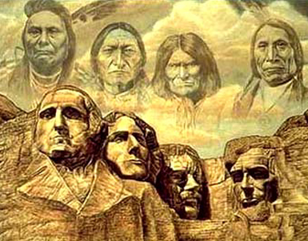

http://reddead.wikia.com/wiki/File:Native-americans-01.jpg

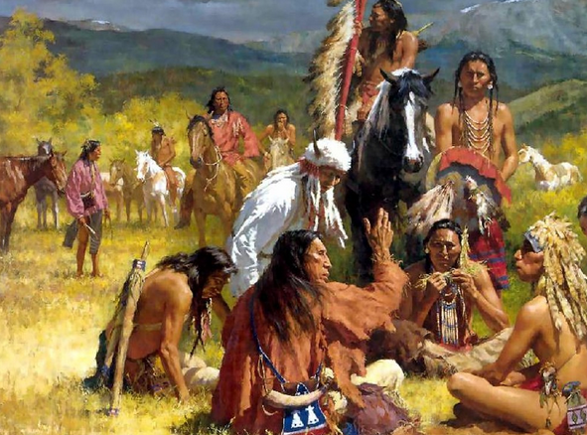

http://aistm.org/cartoons.htm

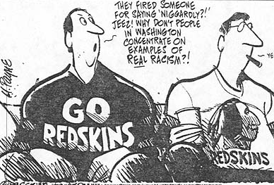

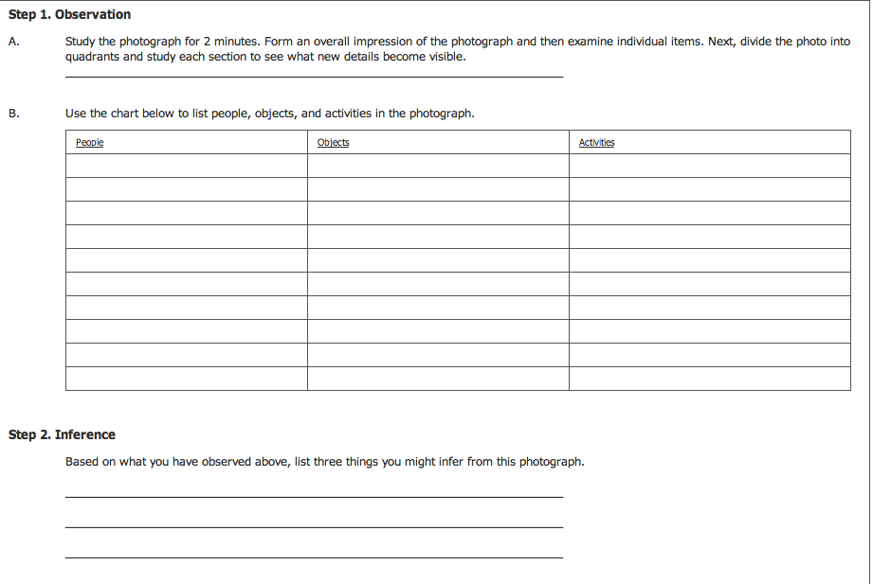
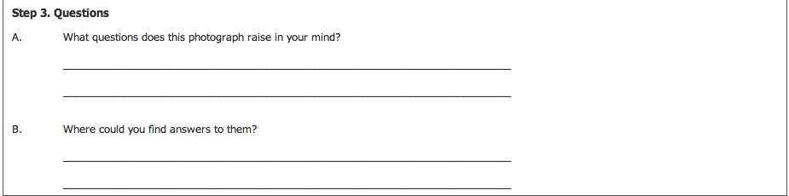

Poem about the rail of tears
You could see the clouds
rolling across the sky
as the day started to rain
teardrops of blood across the land
lost in their visions of doubt
buried in their pain
white man had all the say
we were left to taciturn
as we watched everything burn
and the heavens cried
on the trail of tears
On some beaten shore
we watched the ships come in
one by one, our land wore thin
we could just watch with closed eyes
as the promises made were just lies
they said you don't belong here anymore
behind their mask, they wore a disguise
and the heavens cried
on the trail of tears
Blood spilled on our sacred ground
leaving a unwanted stain
where mighty warriors once made a stand
we never could walk hand in hand
when they lived by so much greed
we watched our people fall
thousands must bleed
still all we could do is try
and the heavens cried
on the trail of tears
Guided by the spirit wind
we held on to our pride
something they could'nt take away
as so many died
through our darkest years
and the heavens cried
on the trail of tears
(spiritwind-2009)
Spiritwind Wood

http://www.poemhunter.com/poem/and-the-heavens-cried-trail-of-tears/

Poem Worksheet

What is the Poem talking about?

Who is the author referring to in the poem when they say “On some beaten shore
we watched the ships come in
one by one”?

What is the mood of the poem?



